Exercise: Practice using JOINS

Lab Instructions
Little Lemon is a family-owned Mediterranean restaurant, focused on traditional recipes served with a modern twist. The Little Lemon database contains many tables of data including Customers and Bookings.
The Customers table contains the following data about each customer:
- Customer ID,
- Full name,
- and phone number.
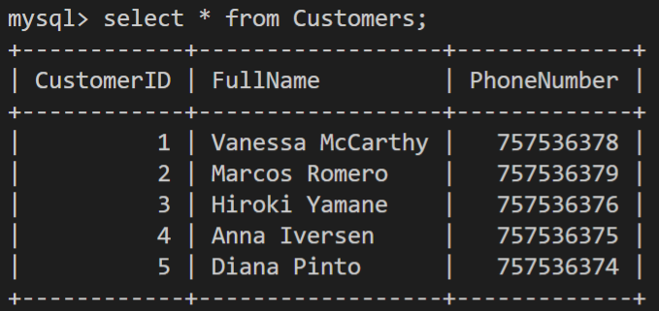mysql list of selected customers
The Bookings table contains the following data on each booking:
- booking ID,
- booking date,
- table number,
- number of guests,
- and the ID of the customer who made the booking.
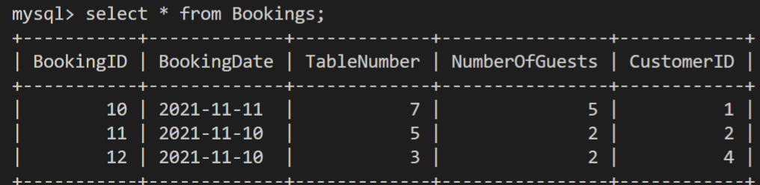

Prerequisites
To complete this lab, you must first have created the Little Lemon database MySQL. You must also have created the Customers and the Bookings tables and populated them with relevant data. If you have not created this database or any of the required tables, then please read the following instructions.
1. The code to create the database is as follows:
CREATE DATABASE lemon;

2. The code to use the database is as follows:
USE lemon;

3. The code to create the Customers table is as follows:
CREATE TABLE Customers(CustomerID INT NOT NULL PRIMARY KEY, FullName VARCHAR(100) NOT NULL, PhoneNumber INT NOT NULL UNIQUE);

4. The code to insert data into Customers table is as follows:
INSERT INTO Customers(CustomerID, FullName, PhoneNumber) VALUES (1, "Vanessa McCarthy", 0757536378), (2, "Marcos Romero", 0757536379), (3, "Hiroki Yamane", 0757536376), (4, "Anna Iversen", 0757536375), (5, "Diana Pinto", 0757536374);

5. The code to create the Bookings table is as follows:
CREATE TABLE Bookings (BookingID INT NOT NULL PRIMARY KEY, BookingDate DATE NOT NULL, TableNumber INT NOT NULL, NumberOfGuests INT NOT NULL CHECK (NumberOfGuests <= 8), CustomerID INT NOT NULL, FOREIGN KEY (CustomerID) REFERENCES Customers (CustomerID) ON DELETE CASCADE ON UPDATE CASCADE);

6. The code to insert data into Bookings table is as follows:
INSERT INTO Bookings (BookingID, BookingDate, TableNumber, NumberOfGuests, CustomerID) VALUES (10, '2021-11-11', 7, 5, 1), (11, '2021-11-10', 5, 2, 2), (12, '2021-11-10', 3, 2, 4);

Task Instructions
Please attempt the following tasks:
Task 1: Little Lemon want a list of all customers who have made bookings.
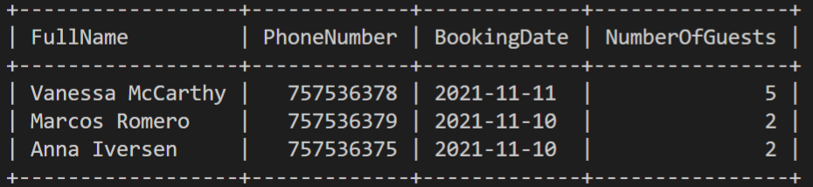
Task 2: Little Lemon want to view information about all existing customers with bookings that have been made so far. This data must include customers who haven’t made any booking yet.
